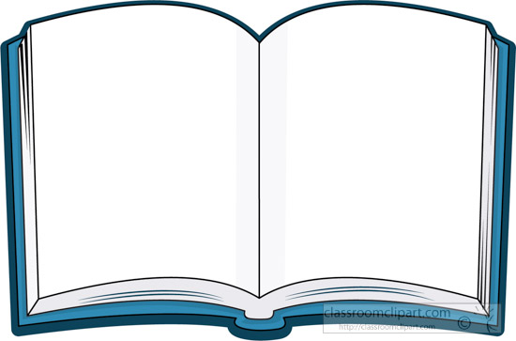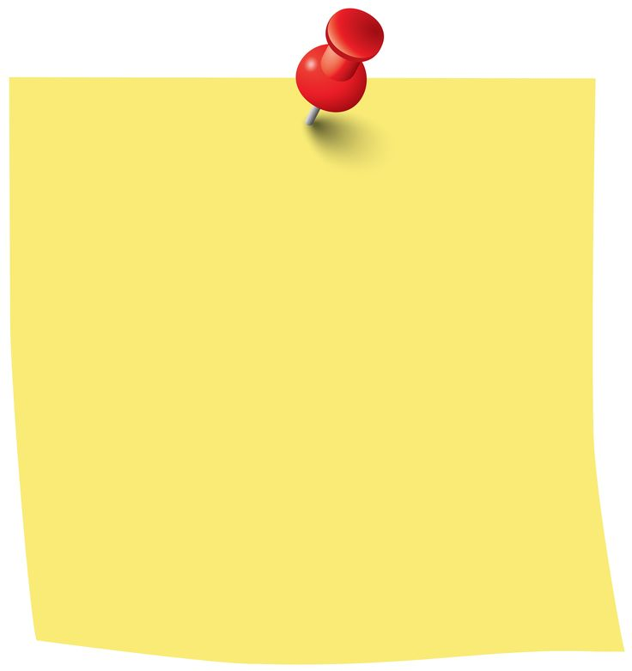

Library visit

The children really enjoyed their visit to the library on Thursday. As we enjoyed looking at the books, the librarians very kindly set aside books the children selected with their names on. To collect your book to borrow, visit the library and pick up a library card so you can enjoy many more books!

Notes

Saturday 18th June- Freckleton Club Day

Wednesday 22nd June- Year 1 Trip to Ribby Hall

History

Start learning about the Royal family and kings and queens throughout history.

There are some great videos on BBC Bitesize.

Find an interesting fact you’d like to share with the rest of the class next week

<https://www.bbc.co.uk/bitesize/topics/zkrkscw>

Weekly Spellings

Practise reading and spelling these words. Can you write a sentence using each word.

called

asked

some

come

people

This week we have been exploring fractions.

Practise halving numbers to 20 on Hit the Button.

Maths

Year 1 Beech Class Homework

Friday 17th June

Please encourage your child to read regularly at home and sign their reading diaries. Help them to sound out any new words using their phonics.

.