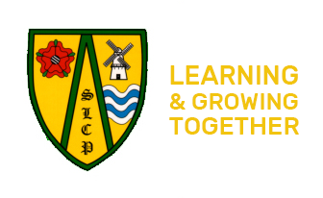

Dear Parent/Carer,

The school has been given the opportunity to take part in a project that will run jointly between schools and Lancashire Constabulary

Operation Encompass is the reporting to schools, prior to the start of the next school day, when a child or young person has experienced, any domestic abuse.

Operation Encompass will ensure that a member of the school staff, (DSL) known as a Key Adult, is trained to allow them to liaise with the police and to use the information that has been shared, in confidence, while ensuring that the school is able to make provision for possible difficulties experienced by children, or their families, who have been experienced a domestic abuse incident.

We are keen to offer the best support possible to all our pupils and we believe this will be extremely beneficial for all those involved.

Signed

Katherine Shuttleworth

Head Teacher

